Russian Revolution of 1917

1. What was the state of Russia in the early 20th century?

2. What effect did World War I have on the Russian people?

3. How did industrialization change Russian society?

Causes of the Revolution
Economic inequality:

Duma:

Secret police:

Proletariat:

World War I:

Rasputin: See next page!

Who’s Who in Revolutionary Russia

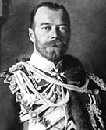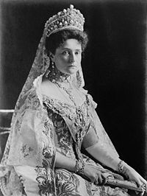
Tsar Nicholas II - Alexandra –

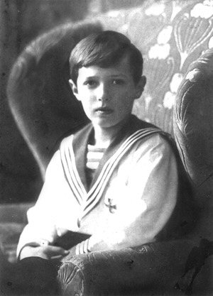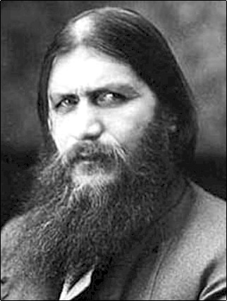
Alexei - Rasputin -

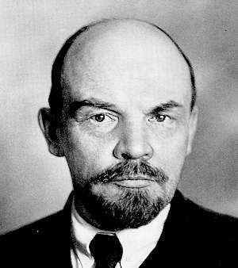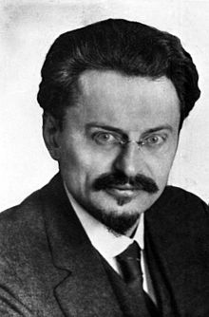
V.I. Lenin – Leon Trotsky -

